Historic Building CPD Day
17 October 2019, Guildford Manor Hotel and Clandon Park

Thank you for booking a place at the above event – the details are as follows:

Start time: Registration from 0900 with coffee and refreshments
Start time 0930
Finish: 1700

Lunch is included – please advise any dietary requirements

Please head to the reception where you will be directed

Morning venue and directions
Guildford Manor Hotel, Newlands Corner, Guildford GU4 8SE

Parking
There is free parking at the venue
After lunch we will make our way over to Clandon which is approx 1.5 miles and 4 mins drive

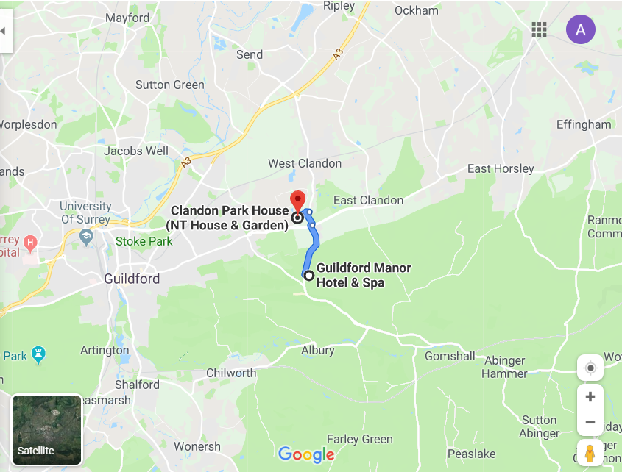

http://www.guildfordmanor.com

Venue contact: Tel: 01483 222624

