**When:** 6 September 2018

**Where:** Chiltern open air museum, Chalfont St Giles

**Time:** 0900 - 1700

**Cost:** £125 + VAT (£150) to include refreshments, lunch delegate notes

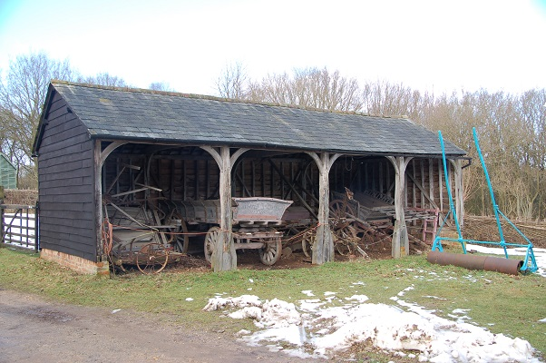

The day’s course will consider in depth three aspects of building conservation.

* The care and repair of historic timber frames and roof structures
* The range of historic roof coverings
* Problems of decay and methods of repair

The venue has been carefully chosen as the museum has a varied and extremely fine collection of rescued buildings dating from the medieval period through to the 20th century. The buildings illustrate a wide range of structures and roof coverings and building materials used at the various periods. The day will include formal Power Point presentations, material handling sessions and first hand observations of the buildings. The mornings presentations will be based in one of the barns and the afternoon will be spent looking at a wide range of buildings on site so come suitably dressed for the weather conditions of the day.

**Main Themes**

* The History and Development of Historic Roof Structures
* Historic Roof Coverings
* The Museum

The day will include formal Power Point presentations, material handling sessions and first hand observations of the building.

Kevin Stubbs will be presenting. A regular presenter on Historic Buildings Kevin Stubbs is a Historic Buildings Consultant and comes with a background of education, archaeology and building conservation. He was Director of Archaeology for the Test Valley in Hampshire and later moved to Hampshire County Council to join the Historic Buildings Bureau, where he became the Principal Buildings Conservation Officer for the County. For eleven years he acted as the Director of a Conservation Centre and now runs his own Historic Building Consultancy and Training Company.

Full details available on the website

**Web:** [www.cpdessentials.co.uk](http://www.cpdessentials.co.uk)

CPD 2018

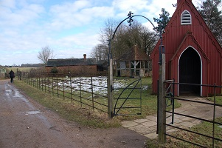

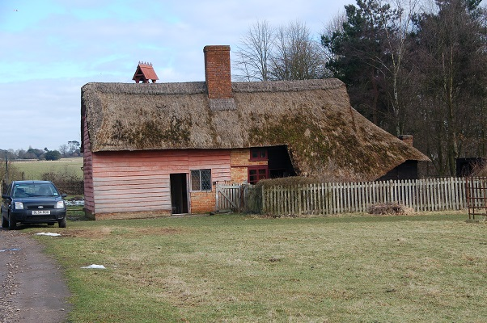

**Historic Buildings**

**CPD seminar**

**Historic timber structures and roof coverings**

**Chiltern open air museum Thursday 6 Sept**

